Exercise 3: Stored Procedures
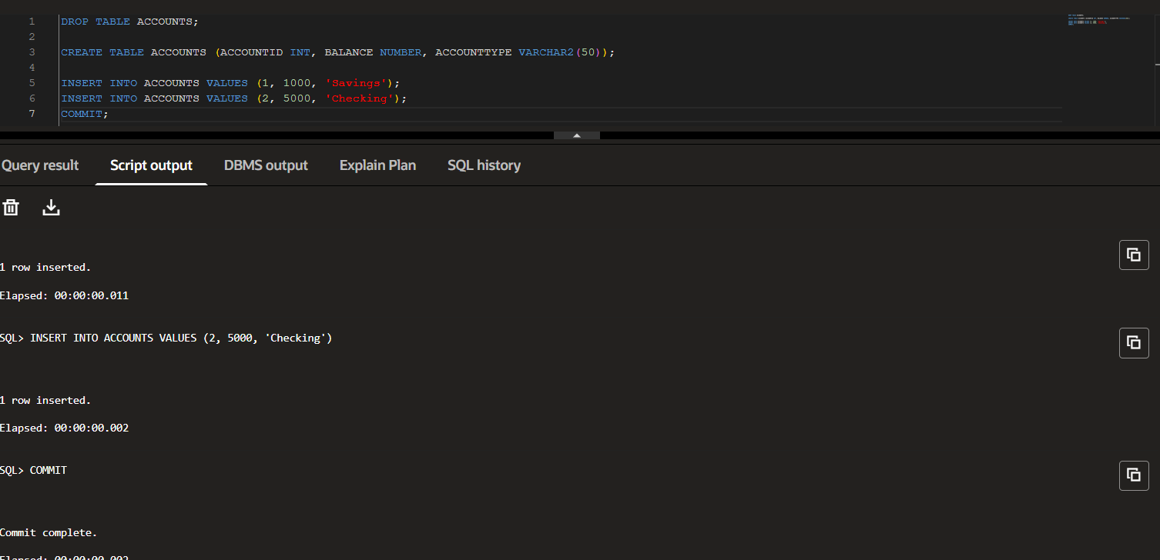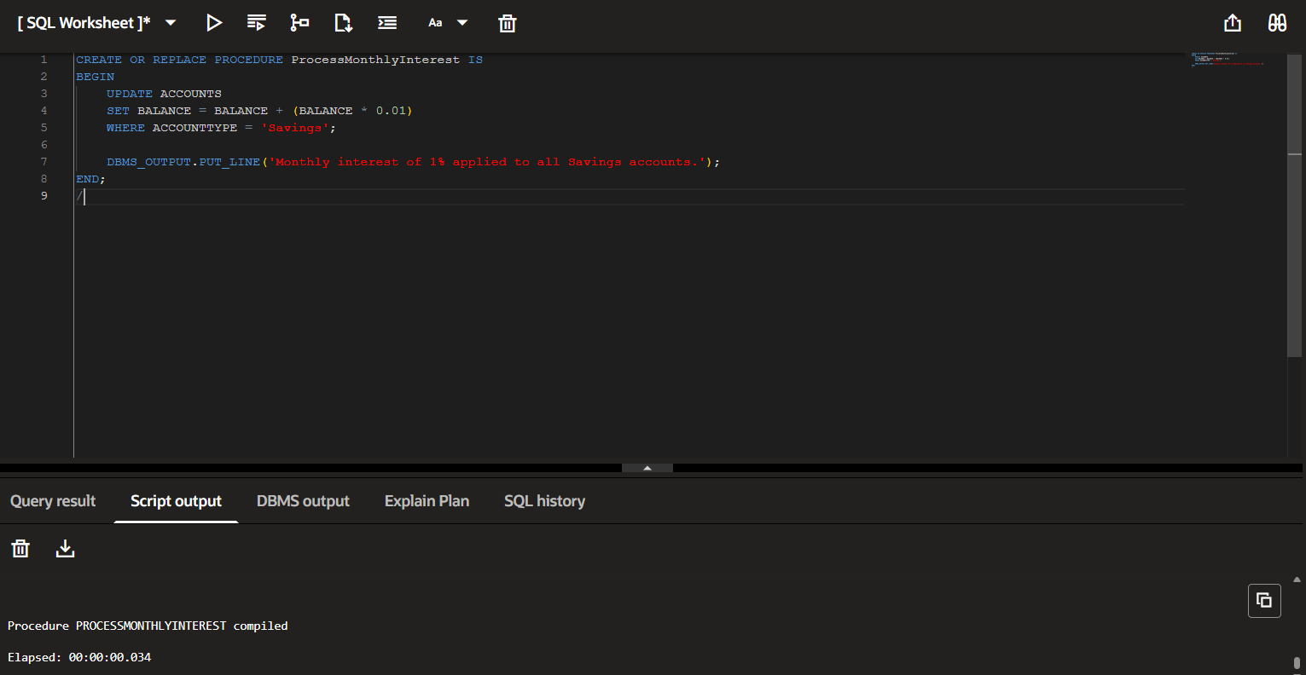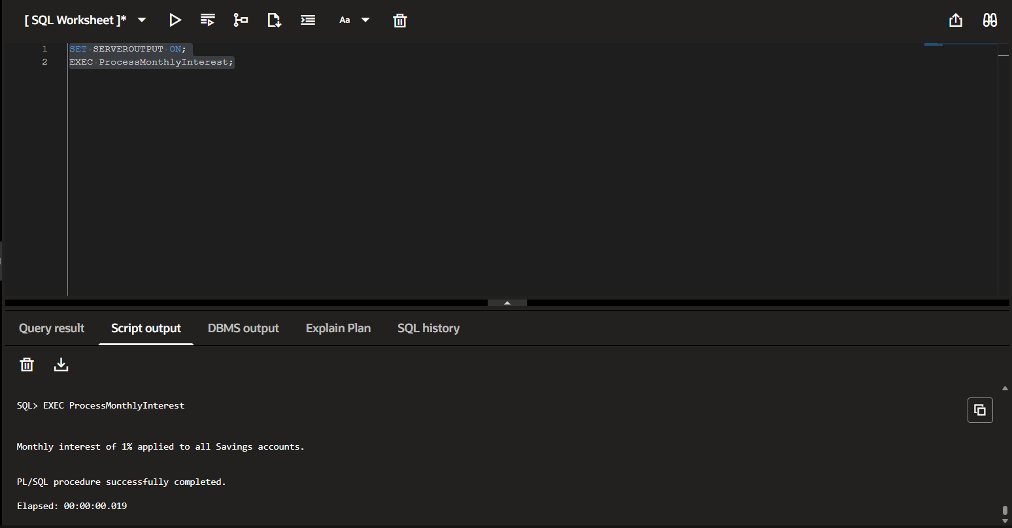

Scenario 2:
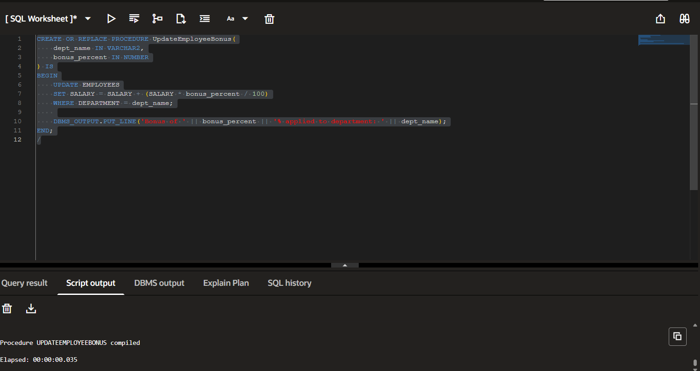
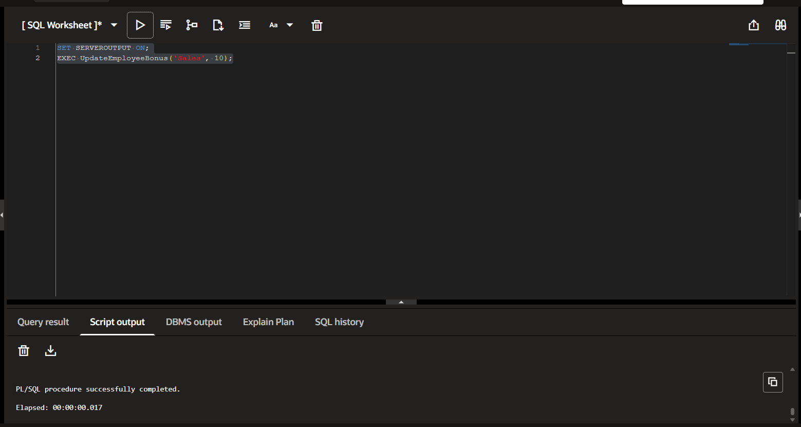

Scenario 3:
CREATE OR REPLACE PROCEDURE TransferFunds(
from_acct IN NUMBER,
to_acct IN NUMBER,
amount IN NUMBER
) IS
insufficient_funds EXCEPTION;
BEGIN
-- Check balance
DECLARE
src_balance NUMBER;
BEGIN
SELECT BALANCE INTO src_balance FROM ACCOUNTS WHERE ACCOUNTID = from_acct FOR UPDATE;

IF src_balance < amount THEN
RAISE insufficient_funds;
ELSE
-- Deduct from source
UPDATE ACCOUNTS SET BALANCE = BALANCE - amount WHERE ACCOUNTID = from_acct;

-- Add to target
UPDATE ACCOUNTS SET BALANCE = BALANCE + amount WHERE ACCOUNTID = to_acct;

DBMS_OUTPUT.PUT_LINE('Transferred ' || amount || ' from Account ' || from_acct || ' to Account ' || to_acct);
END IF;
END;
EXCEPTION
WHEN insufficient_funds THEN
DBMS_OUTPUT.PUT_LINE('Transfer failed: Insufficient balance in Account ' || from_acct);
WHEN NO_DATA_FOUND THEN
DBMS_OUTPUT.PUT_LINE('Transfer failed: One or both accounts do not exist.');
END;
/

